**TITLE**

DESIGN A SYSTEM THAT CONVERTS THE NUMBER GIVEN BY THE USER INTO ITS EQUIVALENT WORD FORM

**A CAPSTONE PROJECT REPORT**

**SUBMITTED TO SAVEETHA SCHOOL OF ENGINEERING**

**OBJECT ORIENTED PROGRAMMING WITH C++**

BY

TALLAPAKA SATHWIK

(192211910)

KAVURI CHAMUNDI CHANDRAHAS

(192211922)

SHAIK IMRAN

(192211925)

**SUPERVISOR**

MRS.KAVIYA

SIMATS ENGINEERING SAVEETHA INSTITUTE OF MEDICAL AND TECHNICAL SCIENCES CHENNAI - 602105

**ABSTRACT:**

A clever C++ application called "Number to Word Converter" is intended to convert numeric quantities into English word forms with ease. This easy-to-use application promotes a better comprehension of numerical data by giving users a straightforward interface to input numerical values and obtain precise word representations. The project's main tool is a powerful conversion algorithm that carefully takes into account a number of variables, including decimal points, place values, and currency symbols. This guarantees an elevated level of accuracy in the conversion procedure, rendering the instrument appropriate for an extensive array of uses.

In addition to being useful in real-world situations, the Number to Word Converter can be used as a teaching tool, providing information on string manipulation, algorithmic design, and numerical representations in relation to C++ programming. All things considered, this project is a flexible, dependable, and instructional resource that enhances the interpretability of numerical data by using linguistic representations.

**INTRODUCTION:**

The "Number to Word Converter" C++ project is an example of a strong and user-friendly utility that connects numerical data and linguistic comprehension. This project seeks to improve user comprehension by offering a smooth conversion of numerical values into their equivalent English word forms in a digital age when numerical information predominates. The application's intuitive interface makes it easy for users to enter numerical data, giving them access to accurate and understandable word representations. The underlying conversion algorithm is highly accurate and can accommodate a wide range of user needs due to its complicated design, which takes into account several parameters such as place values and currency symbols. The project's adaptability is particularly noteworthy because it can handle big numerical quantities and has strong error-handling methods, which add a layer of reliability to the conversion process.

**TECHNICAL SPECIFICATION:**

**Language:** C++

**Paradigm:** Object-Oriented Programming (OOP) and Logical.

**Data Structures:** Array

**Features:** Number to Word Conversion

**Expandability:** The program is designed to Convert upto 100Cr Number.

**DESIGN APPROACH AND DETAILS:**

**Function Definitions:**

ones(int b): Returns the word representation of the ones place of a number.

tens(int b): Returns the word representation of the tens place of a number.

hundreds(int b): Returns the word representation of the hundreds place of a number.

thousands(int b): Returns the word representation of the thousands place of a number.

lakhs(int b): Returns the word representation of the lakhs place of a number.

crores(int b): Returns the word representation of the crores place of a number.

convert(int b): Takes an integer input and returns its word representation.

**Main Function (main()):**

The program starts by welcoming the user and providing information about its capabilities.

It prompts the user to enter a number.

It reads the user input into the variable a.It then calls the convert function to get the word representation of the entered number.Finally, it prints the word representation followed by a period.

**Word Conversion Logic:**

The conversion logic is implemented in a hierarchical manner, starting from the ones place andprogressing to crores.

The functions for each place call the functions for the next lower place, forming a recursive structure.The base cases handle individual digits, tens, and teens.The logic handles special cases like multiples of 10, tens, and limits for lakhs and crores.

**Output:**

The final word representation of the entered number is displayed on the console.

**Limitations:**

The code has a limitation on the input number, explicitly checking for limits in the crores function.If the input exceeds the specified limit (100 crores), the program prints a message stating "Working Limit Exceeded by Given Code!!!"

**User Interaction:**

The program interacts with the user through the console, taking a single integer input.

**Error Handling:**

The code does not include extensive error handling. It assumes that the user will enter a valid integer.

**CODE IMPLEMENTATION:**

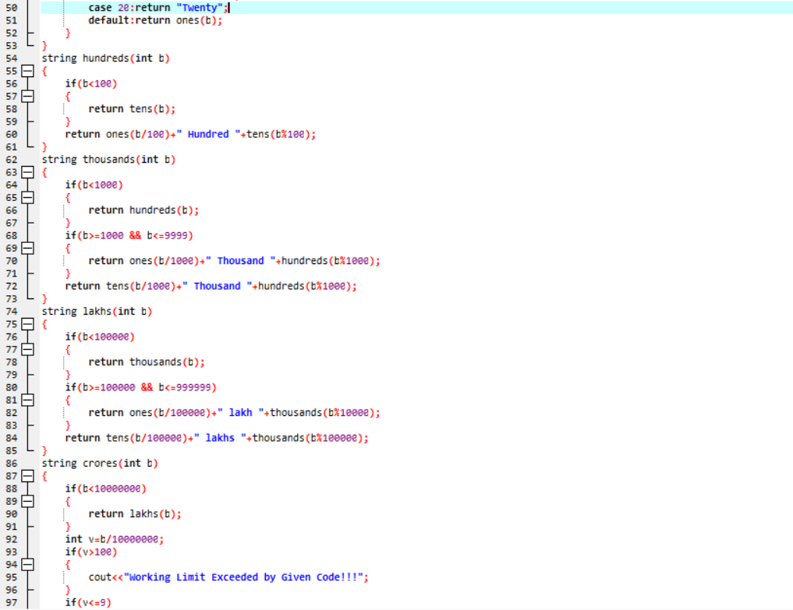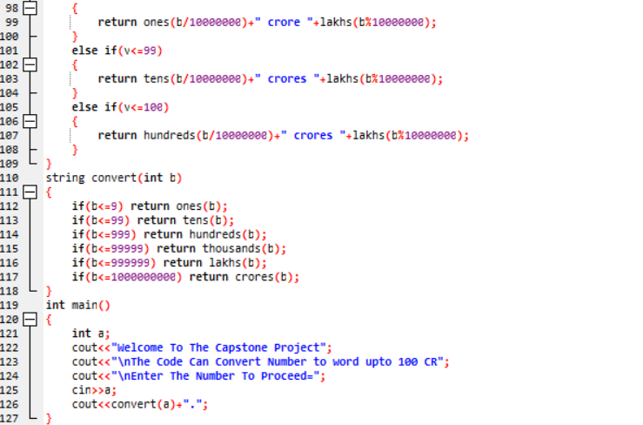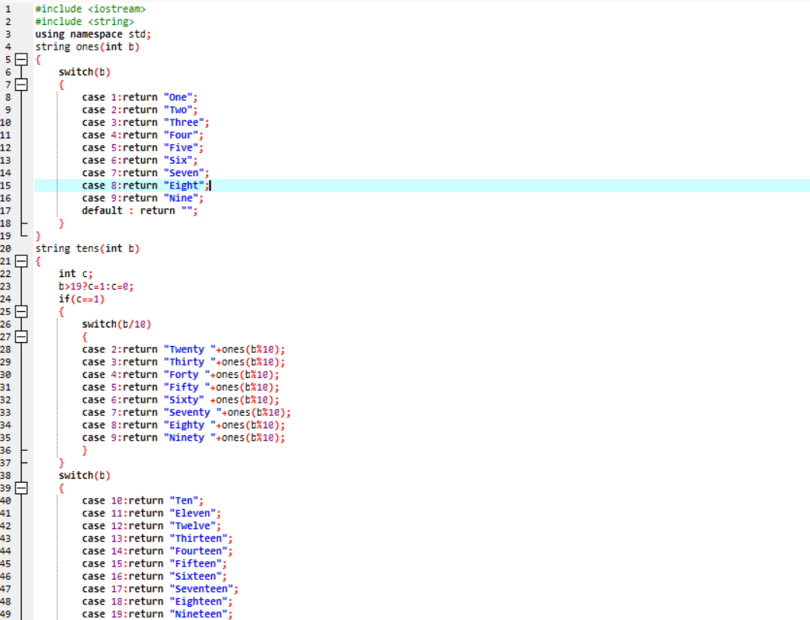

**OUTPUT:**

**RESULT AND DISCUSSION:**

The C++ code converts a user-entered number into its word representation up to 100 crores. It uses a recursive approach, breaking down the number into ones, tens, hundreds, thousands, lakhs, and crores. The main function takes user input, calls the conversion function, and prints the result. The code is functional and straightforward but lacks extensive error handling. It issues a warning when the input exceeds 100 crores. Further improvements could include enhanced error handling and increased flexibility. Overall, it serves as a basic number-to-word conversion utility within specified limits.

**CONCLUSION:**

The provided C++ number-to-word converter effectively transforms user-input numbers into their textual representations up to 100 crores. The code employs a recursive design, systematically handling ones, tens, hundreds, thousands, lakhs, and crores. While functional and straightforward, the program is limited by a lack of extensive error handling and flexibility. It warns users when the input exceeds 100 crores. Enhancements could involve refining error management and expanding the converter's scope. In its current state, the converter offers a practical solution for converting numbers into words within specified constraints.